Reminder: Delco Solar Tours Begin Next Week

Celebrate the U.S. Department of Energy’s National Clean Energy Action Month by Joining the Delco Solar Tour!

Delaware County’s Office of Sustainability, tasked with making the County more sustainable and resilient to the effects of climate change, and Solarize Delco, a local non-profit dedicated to promoting solar adoption and educating residents about the advantages of solar energy, reminds residents that the Delco Solar Tour runs next week from Monday, October 7 through Sunday, October 13.

This multi-date tour enables Delaware County residents to explore solar energy solutions right here in Delaware County by visiting solar installations in their own communities, and provides a unique opportunity for residents, schools, and municipalities to learn about the benefits of generating their own power through solar energy.

Whether you’re considering solar for your home, school, or community, these tours offer a chance to see solar installations up close and speak directly with homeowners, educators, and municipal leaders who have already made the transition. The tours are designed to demystify the process of going solar, offering firsthand insights into the costs, benefits, and practicalities of adopting solar energy.

“Solar energy is a key component of our commitment to a sustainable future,” said Delaware County Council Member Elaine Paul Schaefer. “These tours are a fantastic way for residents to see how solar power can benefit their homes and communities, and to understand how they can be part of the clean energy movement.”

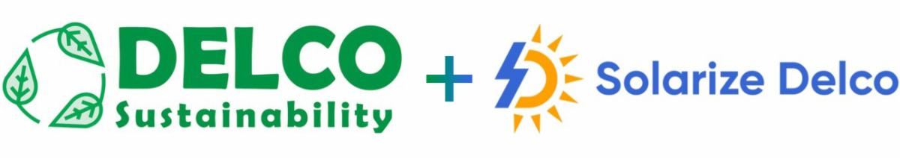

Nationally, Solar Tours have attracted over 150,000 attendees, offering an unparalleled look at the real-world application of solar energy. They serve as a platform for community members to learn about the tangible benefits of solar power, including financial savings, energy independence, and environmental impact. The Delco Solar Tour aims to bring that experience to Delaware County, fostering a community dialogue around clean energy and sustainability.

The tours are free and open to all, with options to attend in-person events between October 6 and October 13, 2024, or participate in a virtual solar tour. This initiative is not just about viewing solar panels; it’s about understanding the potential of renewable energy to transform our communities and reduce our carbon footprint.

For a complete list of tour locations and dates, visit SolarizeDelco.org. To learn more about the tours, explore how to go solar, watch educational videos, or sign up for a consultation with your solarized neighbors, email SolarizeDelco@gmail.com.

Join us and be part of the clean energy revolution right here in Delaware County!

